**March Early Start NWW Projects**

**Prepared by Scott St. John**

In accordance with court orders to provide PIT tag monitoring, USACE began early operation of juvenile bypass systems to better understand juvenile emigration patterns in 2018 (Table 1).

Table 1. Early start sampling information for NWW projects, 2018-2021.

|  |  |  |  |  |  |
| --- | --- | --- | --- | --- | --- |
|  | **Lower Granite** | **Lower Granite** | **McNary1** | **Lower**  **Monumental** | **Little**  **Goose** |
| **Year** | **2021** | **2020** | **2020** | **20192** | **2018** |
| **Screened Units** | 1-6 | 1-6 | 1, 10, 13, & 14 | 1-3 initially  4 - 6 on 3/27-3/28 | 1-6 |
| **Primary bypass operational** | 22-Feb | 20-Feb | 26-Feb | 26-Feb | 20-Feb |
| **JFF watered up** | 1-Mar | 1-Mar | 1-Mar | 7-Mar* | 1-Mar |
| **1st Condition sample** | 2-Mar | 2-Mar | 2-Mar | 9-Mar* | 2-Mar |
| **Sample Frequency** | Daily | Daily | Every other day | Every other day | Every other day |
| **Average Daily Flow (Mar 1-31)** | 41 kcfs | 34 kcfs | 122 kcfs | 50 kcfs | 57 kcfs |
| **Average Daily Spill (Mar 1-31)** | 0.5 kcfs | 0.0 kcfs | 1.3 kcfs | 0.0 kcfs | 0.0 kcfs |
| **Max Daily Collection**  **Date** | 818  3/31 | 3,610  3/31 | 396  3/24 | 36,100  3/25 | 188  3/30 |
| **Total Collection** | 2,647 | 8,099 | 972 | 109,576 | 902 |

1McNary did not conduct early startup operations in 2021 as planned due to mechanical issues.

22019 Lower Monumental delayed sample due to low temperatures (<20°F).

Overall, collection of juvenile salmon and steelhead is relatively low until late March. In 2018 at Little Goose Dam, 645 of the 902 fish (72%) were collected from March 20-31. In 2019, at Lower Monumental Dam, 100,250 of the 109,576 fish (91%) were collected during the same timeframe. The numbers of fish collected in 2019 may have been abnormally high because of Lyon’s Ferry direct release of 150,000 yearling fall Chinook salmon on March 11th. These fish are normally trucked to release sites upstream of Lower Granite Dam, however, a winter storm prevented access to the traditional release sites. In addition, 60,000 steelhead were released early from Lyon’s Ferry Hatchery in 2019 (March 14th and 15th) due to issues with the hatchery water supply. In 2020, total fish collected from March 20-31 include 7,814 of 8,099 (96%) at Lower Granite Dam and 788 of 972 (81%) at McNary Dam. Increased numbers of smolts collected at McNary starting March 24, 2020 was due to the passage of Walla Walla basin hatchery releases. In 2021, at Lower Granite Dam, 2,336 of 2,647 (88%) were collected between March 20-31. Total collection in March for Lower Granite was much lower in 2021 compared to 2020. McNary did not conduct early startup in 2021 (Figure 1).

Chinook salmon made up the highest proportion of PIT-tagged juveniles detected at all locations during all years of early start. Hatchery steelhead were the second highest detected at all locations during all years, except at McNary in 2020 where wild steelhead made up the 2nd highest proportion of detections (Figure 2).

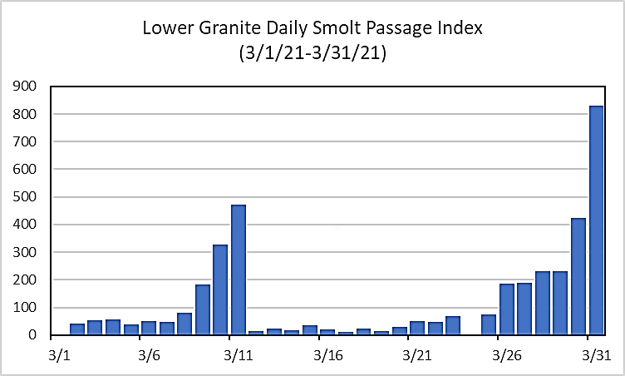

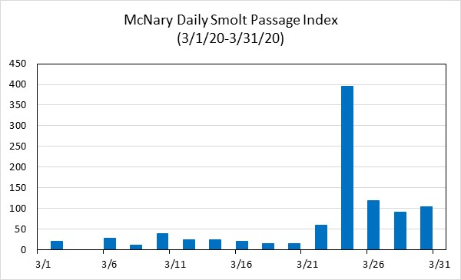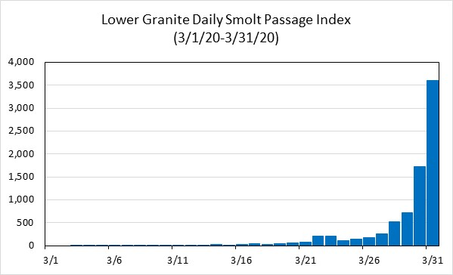

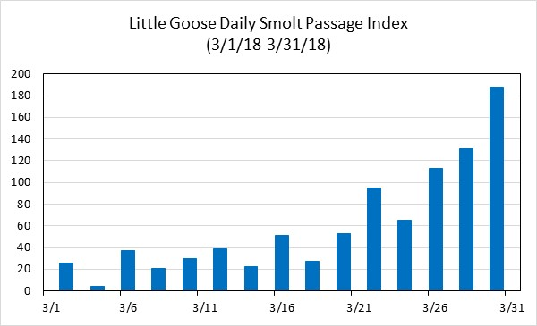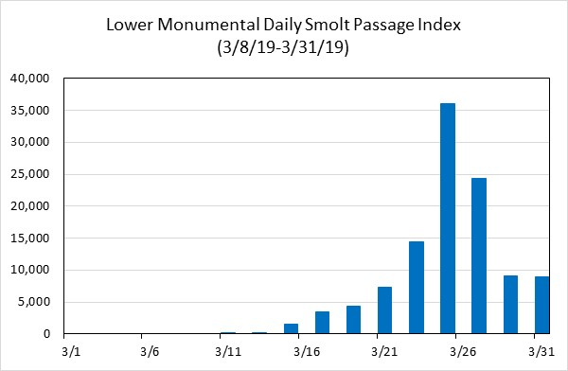

Figure 1. Daily smolt passage index at NWW Projects during March early start-up.

Juvenile lamprey passage index is not calculated at any smolt monitoring facility and total collection is not estimated at Lower Granite Dam. Therefore, juvenile lamprey passage in Figure 3 was tabulated utilizing the number collected in the sample. The number of juvenile lamprey collected at McNary in 2020 may have been influenced by a significant flood event in February.

The 2020 Columbia River System Biological Opinion calls for off-season surface spill in the fall and the spring at all NWW dams to reduce take of overshooting adult steelhead. Spring spill to support adult steelhead passage occurred at through the TSW at McNary Dam during 18 days in March of 2020 and through the RSW at Lower Granite Dam 3 days per week on non-consecutive days March 2-30, 2021. Only about 7% of PIT-tagged juveniles and approximately 60% of PIT-tagged adults were detected over the Lower Granite Dam RSW in March.

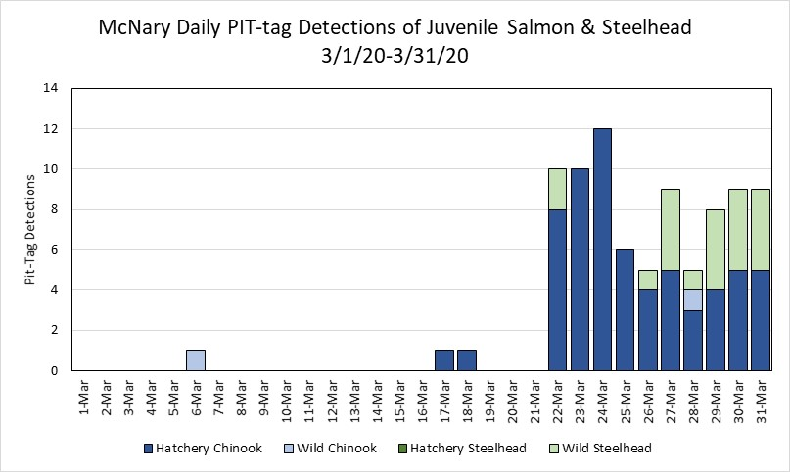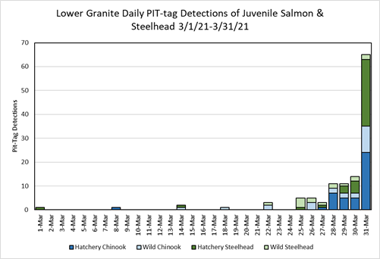

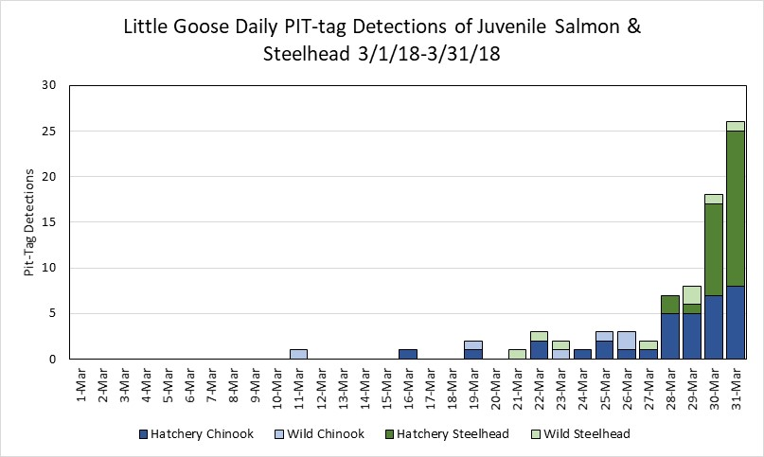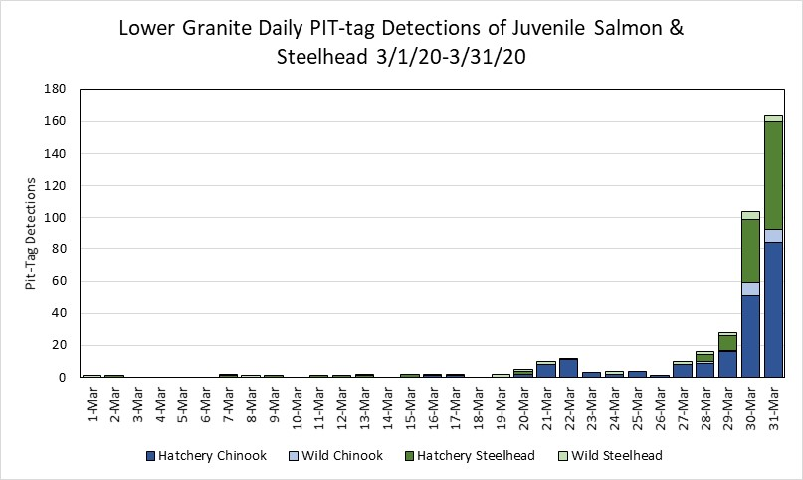

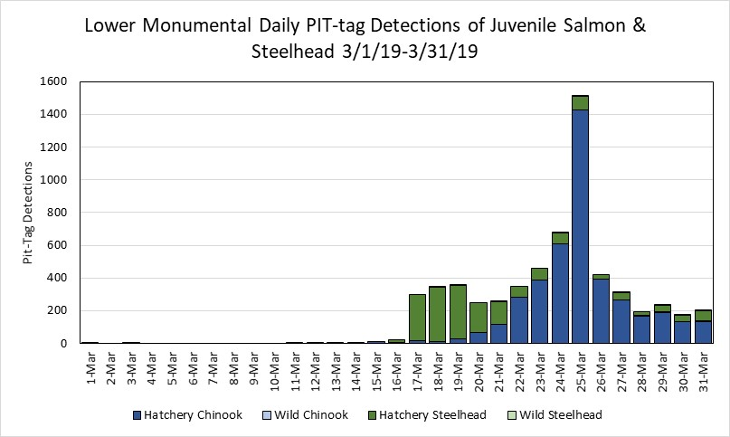

Figure 2. Daily PIT tag detections for hatchery and wild juvenile salmon and steelhead passing NWW Projects during March early start-up.

No overshoot PIT-tagged steelhead were detected within the Lower Granite juvenile bypass system in March of 2021 (Table 2). However, four adult steelhead fallbacks were detected crossing the RSW, a single fish from Lyons Ferry and three from the Tucannon River. Additionally, some of the adult steelhead tagged at Lower Granite Dam as adults fell back and were detected within the Tucannon River.

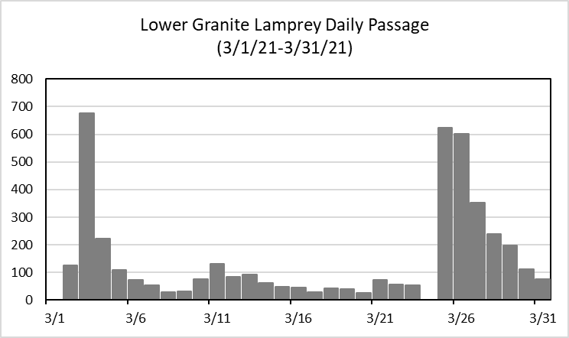

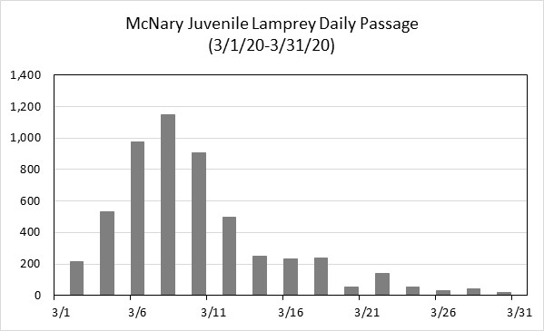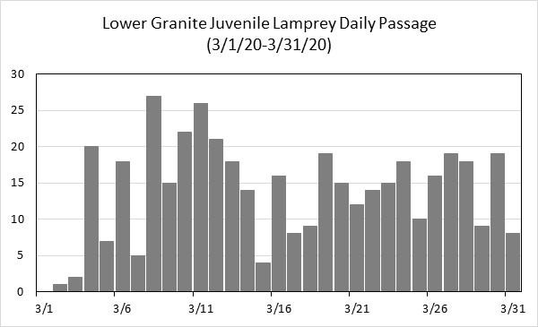

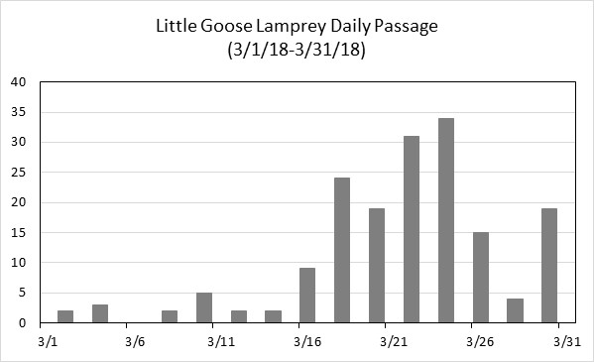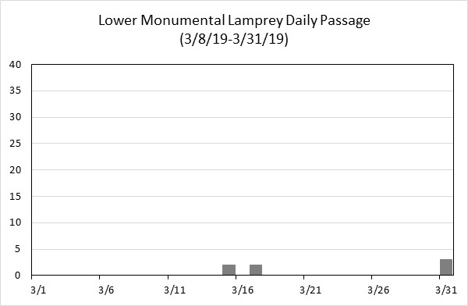

Figure 3. Daily juvenile lamprey sample count at NWW Projects during March early start-up.

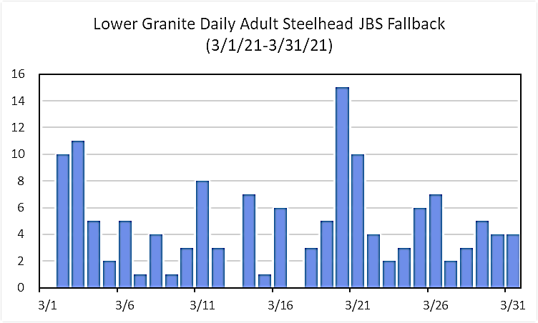

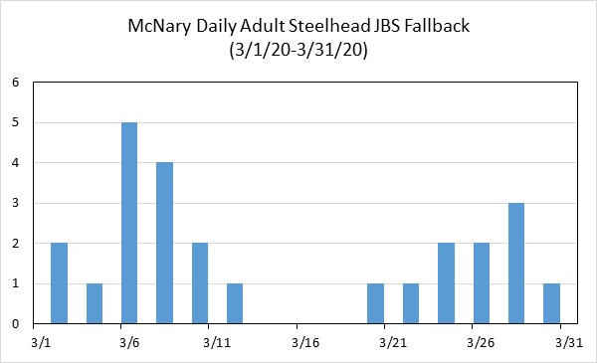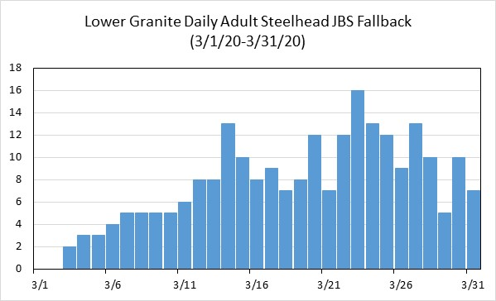

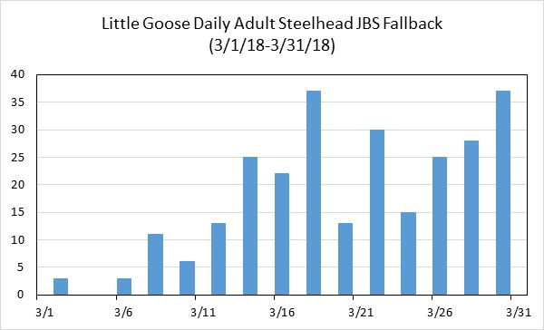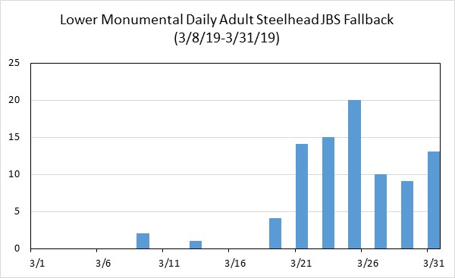

Figure 4. Daily adult steelhead fallback within juvenile bypass systems at NWW Projects during March early start-up.

Table 2. PIT tag detections of Adult Steelhead fallbacks within juvenile bypass systems at NWW Projects during March early start-up.

|  |  |  |  |  |  |
| --- | --- | --- | --- | --- | --- |
|  | **Lower Granite** | **Lower Granite** | **McNary** | **Lower Monumental** | **Little Goose** |
| **Year** | **2021** | **2020** | **2020** | **2019** | **2018** |
| **Overshoots** | 0 | 9 | 3 | 3 | 15 |
| **Unknown origin** | 25 | 19 | 0 | 5 | 14 |
| **Not overshoots (possible kelt)** | 1 | 0 | 0 | 2 | 3 |
| **Total** | 26 | 28 | 3 | 10 | 32 |